“Weirdo Barbie and Punk-Rock Daddy’s Girl: Ambiguity, Gendered Identity and Appearance of Eleven in Stranger Things”
Elizabeth Gackstetter Nichols, Drury University

Originally published in Refractory: A Journal of Entertainment Media, February 26, 2019. Vol. 31.
https://refractory-journal.com/weirdo-barbie-and-punk-rock-daddys-girl-ambiguity-gendered-identity-and-appearance-of-eleven-in-stranger-things/

Abstract: The character of Jane/El/Eleven in Stranger Things appears to the viewer in Season One as a blank slate, free of individuality, gender or identity. Her transformation, over the course of two seasons, allows us to consider the nature of both aspirational identity building through appearance of the kind described by Paul Valery and Nancy Etcoff, and also the sort of identity as gendered “effect” proposed by Judith Butler. Valery and Etcoff’s theories propose an essential being or “self” inhabited in a body that is then expressed through the considered manipulation of appearance, or beauty work. Butler argues that identity, or self, as gendered constructs only exist as “effects” rather than causes. El in Stranger Things offers a unique opportunity to explore these ideas as they are managed both by the character and the program, but also by consumers of the show, who interact with it actively through the practice of cosplay. This study uses a grounding in both gender and beauty theory to discuss the type(s) of identity(s) communicated by the different “looks” of the character Eleven in Stranger Things, with a focus on how cosplayers appropriate and use those looks in the search to say something about themselves.
Introduction
Eleven is a living paper doll, a blank slate on which others can create what they want to see. Both viewers of, and characters in, Stranger Things (Netflix 2016-present) use Eleven (Millie Bobbie Brown) as a template for their own visions, creating identity through her appearance. This paper will use the frame of gender and beauty theory to examine both the way that Eleven is constructed visually within Stranger Things and by its fans. The examination of Eleven’s characterization draws upon textual analysis of the television program itself, published interviews with the creators and actors, and the thoughts of Eleven fans and cosplayers (as communicated in both structured and unstructured interviews). Using the framework of beauty and gender theory as described by Nancy Etcoff, Judith Butler and Pierre Bourdieu, as well as Henry Jenkins’ work on participatory culture, this study will detail the process of collective identity creation that is effected in the appearance of the character of Eleven/El/Jane.
Set in the 1980s in the small, fictional town of Hawkins, Indiana, Stranger Things allows creators Matt and Ross Duffer to use their appreciation for the work of directors like Steven Spielberg and authors like Stephen King to create an “elevated” version of “B-movie ideas” (Nicholson and Hulley-Jones). The series follows the story of a young woman, a pre-teen, with psychic abilities, Eleven, who escapes from a government laboratory where she is being used by unscrupulous scientists to spy on other nations. Eleven does this by navigating another plane of reality called the Upside Down, a dangerous analog to our everyday existence. During her forays into this dark reality, she inadvertently opens a portal from the Upside Down to Hawkins and allows a monster to enter the small town and steal away two young people. The residents of Hawkins, a group of young friends, a single mother and the local police chief then work with Eleven to fight the monster and close the portal.
Throughout the series, we see Eleven as both vulnerable and strong, damaged and super-powered, androgynous and feminine. All of these characteristics are quite literally embodied in her physical appearance, especially in her hair and clothing. Throughout, Eleven is nearly nonverbal, speaking only a handful of words per episode. This makes the weight that her appearance plays in our collective evaluation of her that much more critical. Through two seasons, El undergoes a series of transformations, each communicating (or effecting) a different identity for her character. Eleven initially appears free of individuality, gender or identity. Her multiple transformations demonstrate how both members of her community in the storyworld of Stranger Things and members of the series’ fan community feel empowered to manipulate her appearance in an effort to create meaningful gendered identities. From Eleven’s debut as nearly naked and hairless, to the final scenes of the second season where she appears as a wholesome Daddy’s girl, Eleven’s hair, clothing and cosmetics communicate a series of embodied identities that show how others choose to see, or impose their vision, on her. That the imposition of these different styles does not necessarily define or describe how Eleven perceives and understands herself, confirms Judith Butler’s theories on gender expression and appearance as performative while emphasizing Eleven’s position as a metaphorical doll.
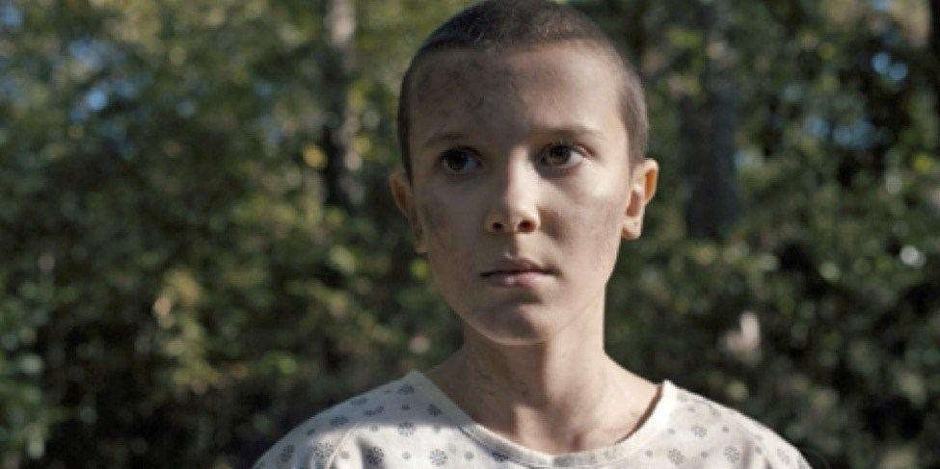Figure 1: Eleven as she first appears (1.01). Copyright: Netflix.
Over the course of the series, Eleven has four distinct styles of overall appearance. When she first appears in Season One, her head is shaved, she looks undernourished and is wearing only a hospital gown. Later, she is dressed in a smocked pink dress, given a long, blonde wig and a blue windbreaker. At the beginning of the second season, she has her own, naturally curly brown hair and wears overalls (and later a modest blue dress). This look is followed by a punk-rock makeover that slicks her hair back, gives her dark eyeliner, lipstick and a black blazer. Each makeover is carried out by other characters with minimal input from Eleven herself. Her appearance thus reflects what other characters within the show (and by extension, the creators of the program) think that she “should” look like.
The wide and enthusiastic fan following for Stranger Things adds another layer to the manipulation of Eleven’s appearance. Fans cosplay Eleven, making their own decisions about both what she should look like and how she should act through the lens of their own rules, aspirations and expectations. The very ambiguity and discomfort of her liminal position within Stranger Things allows fans and viewers of the show to insert themselves and take ownership of the character and her appearance. Thus, both within the storyworld and outside of it, Eleven is a template onto which members of both her society and ours impose their own vision of her identity.
The imposition of other’s visions on the body of young women like Eleven is not a new phenomenon. Women’s bodies have, for centuries, been understood as vessels for the encapsulation and expression of societal norms and values. Thus Butler argues that gender is never the inherent identity of an individual, but rather the performance of anticipated, repeated and ritualistic expectations of appearance and dress. In the case of Stranger Things, the nostalgic and historical frame of the program adds weight to repeated tropes of appearance so they are loaded with cultural resonances and associations built over the decades. Moreover, these different identities built for Eleven exist in tension and discomfort with each other. Eleven and her appearance offer a rich study in contrasts. She is hard and soft, fearsome and afraid, boyish and girlish by turns, each represented on her body and in her appearance. Eleven exists in ambiguity for both other protagonists and for the viewer watching Stranger Things at home. It is this liminality, this ambiguous, uncomfortable positioning that makes her so compelling.
Paper Dolls and Glass Cases
The idea of woman as an unformed being, only brought to life by the outside intervention of society, is hardly a new one. The concept appears in centuries of literature and art, from Pygmalion (Ovid 8CE)to Ex Machina (Garland 2014). In many of these iterations, woman is presented either literally or figuratively as a doll–an object who exists to be molded and shaped, and in the example of Ex Machina, even programmed to reflect her creator’s desires. For centuries women have been expected to conform to societal values, quite literally carrying the weight of morality on their bodies. As Pierre Bourdieu observes, the collective evaluation of women’s appearance “constitutes women as symbolic objects whose being is being-perceived and has the effect of keeping them in a permanent state of bodily insecurity, or more precisely of symbolic dependence. They exist first through and for the gaze of others” (66). For Bourdieu, this means that women are continually placed in the position of being “body-for-others,” dolls on which society arranges and displays their values (66)
The appearance of a woman’s skin, hair and dress have been, and continue to be, particularly intense sites of representation of a community’s values. Wealth, family lineage, moral prudence and virtue worldwide are all commonly understood to be visible on the body of a woman, who stands as a doll, “the female subject in the display case of society,” her “corporeal care” in dress, grooming and managed appearance conforming to the collective “norms of etiquette and propriety.” (Di Mare 20). Symbolic representation of a culture’s laws and values is visible in the appearance of women’s hair, skin and clothing insofar as each can signify wealth, social class, ethnicity, race, fertility and desirability. As the evolutionary psychologist Nancy Etcoff argues, “we love to look at smooth skin, thick, shiny hair, curved waists and symmetrical bodies because in the course of evolution the people who noticed these signals and desired their possessors had more reproductive success. We are their descendants” (Etcoff 24). Indeed, some would argue that fashion is about two things: sex and status (Etcoff 209, Barnes and Eicher, Ayman and Kaya, Awasthi).
Clothing is a significant element of what Butler terms the “Law of the Symbolic” (74). The law, created by society, proscribes different elements of dress and appearance for the performance of different genders, and as Butler notes, “we regularly punish those who fail to do their gender ‘right’” (140). All of this, as Butler observes, falls into the “grid of cultural intelligibility” (208) of a society that organizes itself and the appearance of its citizens within norms of a heterosexual binary (30). Conformity to, or rebellion against those norms of appearance then can communicate an individual’s willingness to embrace the Law or reject it (Lunceford). The choices each of us make in getting dressed each day communicate a great deal about the identity that society expects from us, also the identity we would like to embody. Additionally, in fictional storyworlds, the appearance of skin, hair and clothing is an important element of a character’s representation. Thus the use of Eleven’s character to model so many different expressions of identity, is of interest. I will show how Eleven is manipulated into four distinct looks in Stranger Things, paying attention to those who impose their visions on her. Then, I will examine the views of fans and cosplayers, investigating how their visual and theoretical dialog with the character continues the work of overlaying expectations and desires on the body of Eleven, like clothing on a paper doll.
Weirdo Barbie
The first time we see Eleven in Stranger Things, the camera very deliberately moves over her body, bottom to top (1.01). We see her naked feet on a surface of pine straw and her legs barely covered by a stained and ripped hospital gown. As the camera continues upward, we see her hands hanging limp before the camera stops on her face, which is strong, angular and solemn, with smooth (but dirty) white skin and large brown eyes. Her hair is very short, nearly shaved. This initial presentation is that of a young, androgynous person. If we had not heard her referred to as “the girl” in the scene immediately previous, we would not be sure of her gender identity. Indeed, the first person she encounters in the show, the restaurant owner Benny, initially mistakes her for a boy (1.01). The Stranger Things show bible, titled Montauk, described Eleven as “The Outsider,” noting that “If Mike is the ‘Elliot’ of our show, then Eleven is the ‘E.T.’” (Duffer Brothers). This description of Eleven as literally alien is telling in the way it situates her as Other, uncomfortably outside, androgynous and unknowable.
The vision of Eleven as neither clearly male nor female is matched by the conflict between the extreme vulnerability of her image and the power she soon displays. She is nearly non-verbal. She is barefoot and dirty. She is very thin, with little hair. She is clothed, but only barely, in attire that suggests illness and frailty. Furthermore, the tattoo on her arm above her wrist, “011,” is eerily reminiscent of those inflicted upon interned Jews during the Holocaust.^{[1]}Even after Benny gives her more substantial clothing, a far too large t-shirt, this only emphasizes Eleven’s frail, skinny and powerless appearance. It isn’t until she is seated in Benny’s restaurant, wearing the huge shirt, that she displays telekinetic power of a startling efficiency and strength. This is our first glimpse of the discordant nature of Eleven’s identity. While all the scenes prior to this one present her as frail, scared, damaged and young, when she chooses to stop an electric fan with her mental power, the camera angle shifts to show her face from above as she tilts her head forward, focusing on her shaved head and intense stare. When she has accomplished her goal, she casually wipes her hands in satisfaction.
This image of Eleven as frail yet powerful alien outsider is maintained when she meets the boys Mike (Finn Wolfhard), Dustin (Gaten Matarazzo) and Lucas (Caleb McLaughlin) in the woods at night, still wearing the too-large shirt, and soaking wet. The boys, once back at Mike’s house think she’s sick or at the very least mentally unstable: “psycho” or “mental” (1.02). Here, attention is drawn to what Melissa Kaufler calls the Frankensteinian nature of Eleven’s character, a part of the damaged element of her persona that allows for her monstrous power. However, despite her powerful mind and telekinetic ability, she only truly scares the boys by beginning to take off her large t-shirt in front of them when they offer her dry clothes. Lucas and Dustin consider it proof that’s she’s crazy, while Mike is attracted to her. Thus, their fear is revealed as nascent sexual awareness and desire. For the boys, this is deeply unsettling. She does not fit into any of the categories that they are comfortable with: not sister, mother or pretty girl at school. It points to a friction that the show will struggle with in both seasons: how to reconcile Eleven’s power with a need for her to be tame, pretty and safe.
Adolescent sexuality, as some scholars propose, is fully formed by puberty, but is feared and threatened by adult discomfort with children’s awakening (Fortenberry). This is sometimes described as the tension between sexual motivation and the need to control sexuality: “dilemmas of desire” for both adults and children (Tolman). For the boys within the show, their budding adolescent sexuality recognizes a desirable object. Their learned behavior, however, requires control. They must manage their own behavior, and monitor hers, disallowing her from engaging in actions that make her more desirable to them. Eleven, having not been enculturated into these norms, innocently acts in ways that threaten their ability to control their reactions. Their response is to ensure that she is fully clothed, and therefore “safe,” unchallenging to their ability to manage their sexuality.
Eleven’s appearance in these first two episodes is worth discussing. Eleven is the last of a series of test subjects in Hawkins Lab, part of a project to study mental abilities including telekinesis and astral projection, used to spy on the Soviets. Lead scientist Dr Brenner (Mattew Modine) is cold, remote, and manipulative, and the relationship between him and Eleven is one of abusive father “Papa” to an abused child (1.04). Brenner’s apparent control over Eleven’s appearance is just one element of this manipulative relationship. If we think more at length about the semiotics of the hospital gown, it becomes even more disturbing. There is no immediately obvious reason for Eleven to be dressed in a gown. She is not physically ill or injured. However, anyone who has had to wear a hospital gown knows that it is the flimsiest, and least comforting of garments. It leaves the wearer exposed. It does not keep one warm. It is anonymous and belittling. It is designed to allow medical professionals unfettered access to the wearer’s body at all times, for examination and probing. Eleven’s gown suggests that she has no control over her own body, while the (uniformly male) forces that control her have constant access.
While the way that Eleven is dressed by Brenner is chilling, the boys’ makeover of Eleven is not any less controlling. First, they change her name, calling her “El” instead of Eleven or simply “weirdo” (1.02). Since her name is one of the only elements that Eleven has carried with her as her own from the lab, its rejection highlights how the boys brush away her personal identity. In a more obvious rejection of Eleven’s agency, the boys (in a sequence that looks nostalgically back at Spielberg’s E.T. ) dress her in a smocked pink dress and long blond wig. They need to sneak her into the school and know that they cannot take her dressed as she is. “I mean,” says Lucas, “LOOK at her!” (1.04). It’s obvious to the three of them that her appearance is well outside the social norms of the community, Butler’s “grid of cultural intelligibility,” for girls. Eleven’s feminine sexual identity having been confirmed, the boys do not consider passing her off as a boy, but instead set out to dress her according to what they expect a girl to look like. In an extended montage, we see the boys create this costume. It includes make-up application, the long blond wig and a pink, smocked, long-sleeve dress of the type a very young girl would wear. When she emerges from a bedroom transformed, Dustin and Mike agree that “Wow, she looks…..pretty.” (1.04). Eleven learns this lesson quickly, and moving to look at herself in a mirror, repeats the word: “pretty.” Pretty means “pleasing by delicacy or grace; having conventionally accepted elements of beauty; appearing or sounding pleasant or nice but lacking strength, force, manliness, purpose, or intensity” (Merriam-Webster). All of these possible definitions are relevant here. By making Eleven into a “pretty” girl, the boys have remade her as a person who fits the “conventionally accepted” elements of appearance for a young girl, who is delicate and weak. Furthermore, as the dictionary suggests, making her pretty takes away her power and agency as it strips her of “purpose or intensity.” In this way, “pretty” is culturally intelligible as it allows Eleven to fit into a traditional position in the heterosexual binary, helping Eleven fit into society’s notion of how things should be and how girls should look.
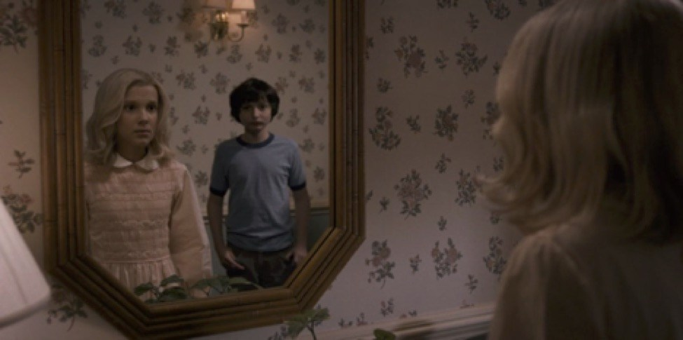Figure 2: Eleven’s first makeover (1.04). Copyright: Netflix.
Even if the boys had only chosen to put a wig on Eleven, that likely would have been enough to effect the transformation from “weirdo” into “girl.” Such is the symbolic power of long hair on women (Nichols). Hair is an especially intense site of racial, class and gendered identity. Across the world, cultures proscribe specific rules to both male and female hair in regard to style, length and coverage. Within the cultural framework of the United States in the 1980s, long hair on men (as in the 1960’s and 1970’s) was a mark of rebellion against both prevailing social norms of respectability and previous generations’ social norms of beauty (Luther Hillman). Long hair for men, then as now, was also was a direct affront to the construction of a heterosexual binary through appearance (Butler). Short hair for women was equally provocative. Especially in the 1980s, hair was especially prominent on women, who curled and teased their hair in search of volume and lift. Even in present day United States, short hair for women is outside the norm, and prominent meninist thinkers evaluate women with short hair as “damaged,” since men prefer long hair on women (Sonofra). This reading of short hair appears in perfect agreement with the representation of Eleven as scarier, more powerful and more injured as a consequence of her short hair.
Eleven’s two hair styles in Season One are in direct tension with each other. The dissonance between the two looks for Eleven continues beyond her hair, however. Beneath the doll-like costume of respectability and normalcy that the boys have created for her, Eleven is still powerful, also still hurt and confused. This is depicted most powerfully in “The Monster” (1.06) where Eleven is called on to help the three boys, revealing her powers, and not surprisingly, losing some of the “Barbie” look to let the “weirdo” appear. Eleven reappears after an absence to rescue Mike, confronting a pair of bullies. She still wears the pink dress and blue jacket that the boys dressed her in, but has lost the blonde wig. The pose she adopts when using her power, legs spread and head tilted forward, foregrounds the very short hair on her head. In this scene, she has also lost the soft makeup and lip gloss the boys applied, and instead as she uses her powers, blood drips from her nose to color her face.
Facial cosmetics, as Nancy Etcoff observes, are at least forty thousand years old (96). For that long, they have served to paint human bodies to both hide imperfections and make the body appear more appealing and attractive. Blush on the cheeks and lipstick on the lips mimics the rush of blood of sexual excitement in women, as well as being “visible from afar and emotionally arousing” (Etcoff 101). Cultural norms instruct women to apply make-up, so the boys in Stranger Things consider cosmetics both a necessary part of Eleven’s makeover and a reason to find her then startlingly “pretty.” This application of cosmetics can be contrasted with the red of the blood that comes from Eleven’s nose when she uses her mental powers. Women’s blood is the subject of varying connotations and culturally understood meanings. For example, women’s blood can be a signal of sexual arousal when seen under the skin in flushes and blushes. Menstrual blood, however, is widely subject to taboos, and it has the power to create an atavistic response of fear and revulsion for many men. Julia Kristeva called this menstrual blood part of “the abject,” the primal and profane parts of women that must be controlled by the symbolic order. Indeed, some note that Eleven’s blood and power is part of a long history of “women’s stories” in horror fiction, where women represent the irrational, unknowable and uncontrollable in the face of men’s desire to keep them contained (Carruthers).
When Eleven uses her mental powers and displays blood dripping from her nose and ears in “The Monster” she presents an image that is uniquely discomfiting and dissonant. She wears a little girl dress with knee-socks, but has the shaved head of a Holocaust survivor and a face that drips with blood, revealing her secret powers. Then she faints, while remembering abuse at the hands of “Papa.” At the end of the scene Dustin sums it up neatly, famously shouting at the backs of the retreating bullies: “She’s our friend! And she’s crazy!” (1.06).
This damaged, conflicted girl was slated by the Duffer Brothers to be killed off at the end of Season One (Siebert). Eleven was to sacrifice herself to save the boys and the dimension they live in, in the season finale. In her final confrontation with the Demogorgon, Eleven appears as an irrationally powerful and dangerous demon-slayer, with a shorn head, dirty dress and hollow face, blood dripping from her nose and ears. She pushes past the boys, who are trying to hold off the monster, looks over her shoulder to say goodbye and lifts one hand to unleash her telekinetic powers, disappearing with the monster as the portal is closed. Neither the boys nor viewers see her again in Season One, so all assume she is dead. Having presented us with this young, powerful, vulnerable girl, the series maintains its “grid of cultural intelligibility” (Butler 208), resolving the tension by removing the figure who does not fit.
Punk Rock / Daddy’s Girl
When we meet Eleven again in Season Two, she is once again confined and under the control of a father figure. In this case, it is Police Chief Hopper (David Harbour) who has taken her in. Hopper is less abusive than Brenner and obviously cares for Eleven as a stand-in for his daughter, who died young. Yet Hopper is very protective and will not allow Eleven to leave the small cabin where he has hidden her, disallowing any communication between Eleven and the boys. She does have a television, however, and Hopper reads to her and teaches her new words.
When we see Eleven for the first time in Season Two, she is dressed in blue jean overalls and a slightly too big, long-sleeved, gray sweatshirt, the collar of another shirt just visible below. Her hair has grown into clearly feminine tousled curls over her forehead and ears. She is clean and appears uninjured, her skin is pale and clear, her eyes still large and lips pink. It’s an innocent image, and very different from her depiction at the beginning of Season One, in more ways than one. There is no lingering shot that traces her entire body in the first scene she enters the room and immediately seats herself behind a table. She is protected, not on display for our evaluation. Her clothing further communicates this image of protection and security. Whereas the hospital gown of Season One was the flimsiest and least protective garment that she could have worn and still remain clothed, the overalls are sturdy and undamaged. The discomfiting access to the young girl’s body that the viewer was allowed in the first season is prevented by layers of clothing that cover all of her skin except her hands and face.
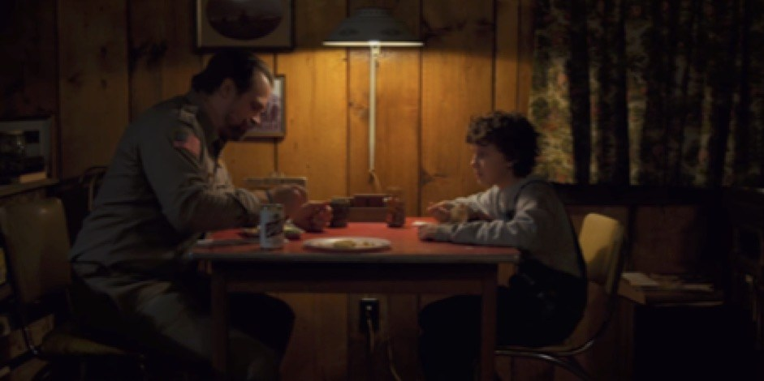Figure 3: Eleven with Hopper, her surrogate father (2.01). Copyright: Netflix.
This first scene also establishes the father/daughter power relationship between Eleven and Hopper. The table comes up almost to her armpits, making her appear young and small. Though Hopper arrives home late and Eleven has been worried, he immediately takes control, lecturing her on “the rules” and instructing her on the proper way to describe the time. He does this while looming over the table in his police uniform and appears symbolically dependent. Eleven’s clothing here, while symbolic of protection, is also symbolic of ownership and place. She is now “Daddy’s Girl,” following directions, making supper and fitting clearly and comfortably into the heteronormative symbolic order that Hopper represents. Her appearance is wholesome. It is not the exaggerated Barbie that the boys costumed her as, but neither is it the look of a “weirdo” or “psycho.” Eleven’s look at this point is very similar to that of Joyce Byers (Winona Ryder) or her Aunt Becky (Amy Seimetz), whom she meets later in the season. They are both mother-figures who protect their families and serve as caretakers, also as advocates for weaker members of their families. While Joyce is arguably a very strong figure with her own agency, she is still driven by her position as a mother. Consequently, both women fit into a grid of cultural intelligibility where mothers nurture, protect and self-sacrifice..
The presentation of Eleven as a clean, well-taken-care of but trapped Daddy’s girl lasts until she finds evidence of her mother that Hopper has hidden from her. At this point (2.05) Eleven goes in search of her mother and learns that she has a non-biological “sister,” another of Dr. Brenner’s laboratory subjects, Eight (Linnea Berthelsen).Eight will undertake the last make-over in Eleven’s trajectory. The meeting with her mother is a turning point for Eleven. She finds out that the name her mother gave her is Jane, and that her mother is in a catatonic state (thus an almost literal example of Kristeva’s abject, irrational feminine). They are only able to communicate telepathically, a possibility signaled by her mother’s bloodied nose. Through her mother’s memories, Eleven sees her sister Eight and is prompted to search for her lost sibling.
The episode in which Eleven finds and meets Eight (2.07) has been described as controversial by both fans and media journalists (Menta, Wigler). The Duffer Brothers explained that their aim was to mirror the scene in The Empire Strikes Back where Luke goes to Dagobah to discover more about himself (Wigler). The episode could be seen as risky as in it control of Eleven and her appearance moves from the province of men to women. Eight is revealed to be on a crusade to punish those who experimented on the girls in the lab; she and her gang of male and female assistants track down former lab employees and kill them. Eight uses her own mental powers in this fight, and enlists Eleven to do the same, effectively trying to turn her to “the dark side,” in Star Wars parlance. As part of this effort, Eight effects a transformation in Eleven’s appearance.
In a montage sequence very similar to that in Season One, Eight and a female member of her gang, in the run-up to a mission to assassinate a former guard at the lab, initiate Eleven’s make-over. The two women dress Eleven in black (black t-shirt, black men’s-style blazer, black bandana around her wrist), slick back her hair, smudge her eyes with black eyeshadow and color her lips a dark red. The makeover is set to the soundtrack of “Dead End Justice” by the (all-female) band The Runaways. Once complete, the gang does not pronounce Eleven “pretty,” but rather “bitchin’” (2.07). Again, as with the boys Season One, Eleven’s makeover is submitted to the frankly evaluative gazes of the male and female gang members who look over and approve of her appearance.
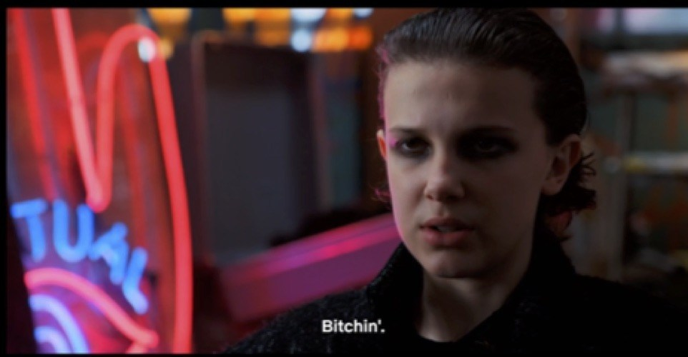Figure 4: Eleven’s ‘bitchin’’ makeover (2.07). Copyright: Netflix.
Eleven’s makeover is a significant change from the wholesome girl who lived at Hopper’s cabin, and once again signals marginality and non-conformity to the symbolic law of gender. The look is androgynous, minimizing the femininity of her hair and hiding her form. It mimics somewhat Eight’s style (which is reminiscent of Janet Jackson in her film clip for the 1986 song, “Nasty”), but is less overtly feminine. In fact, costume designer Kim Wilcox revealed in an interview that this look for Eleven was based on British punk rock singer Siouxsie Sioux, of Siouxsie and the Banshees (Fishman). The Siouxsie reference, however, does not explain Eleven’s new slicked-back hairstyle, as Siouxsie had a gravity-defying spiked hairdo. What we can read in Eleven’s hair is an internal referencing to Eleven’s Season One shaved head. The shaved-head look, as I’ve observed, communicates danger, irrationality and power. When Eleven uses her power, her forehead tips forward, foregrounding the non-conforming hairstyle and putting the viewer’s attention on the power of Eleven’s gaze. The makeover in Season Two which slicks her hair back off her face and forehead allows the intensity of Eleven’s eyes to communicate the internal, mysterious strength that allows her to manipulate space and matter. The makeup further highlight her eyes; it and the dark red lipstick work with the blood from her nose to create an image of power and danger.
This dissonant appearance aside, Stranger Things still reveals itself in maintaining the normative order. In Season One this was accomplished by having Eleven “die” at the end, when Eleven is no longer “pretty,” in the conventional, pleasant and weak sense defined earlier. She has reverted to an abjectly primal appearance that is threatening to the normative order of Hawkins. When Eleven closes the portal and disappears, her dissonant presence is removed. The final scenes of episode 1.08, “The Upside Down” show that Hawkins is back to normal, with Mike and Will’s families cooking, eating and relaxing in time for Christmas.
In the Second Season, the tension between Eleven’s power and the show’s desire to make her “pretty” is effected with one final transformation back into Daddy’s girl. This begins when Hopper tells Eleven that he is ok with her new appearance: “I don’t hate it, by the way, this whole…..look. It’s kinda cool” (2.09). That approval is important, as it allows Eleven back into the normative order by showcasing paternal dispensation or approval of her transgression. In the Season Two finale “The Gate,” then, we are taken to a school dance, where Eleven shows up to dance with Mike. We see Eleven enter the gym, and we (as well as Mike) are given ample opportunity to take in her appearance: the punk rock look is gone, replaced by a demure polka-dot chambray dress, carefully curled and coiffed hair, girlish purple eyeshadow and pink lip gloss. Mike’s first words to Eleven, are, of course “you look beautiful” (2.09).
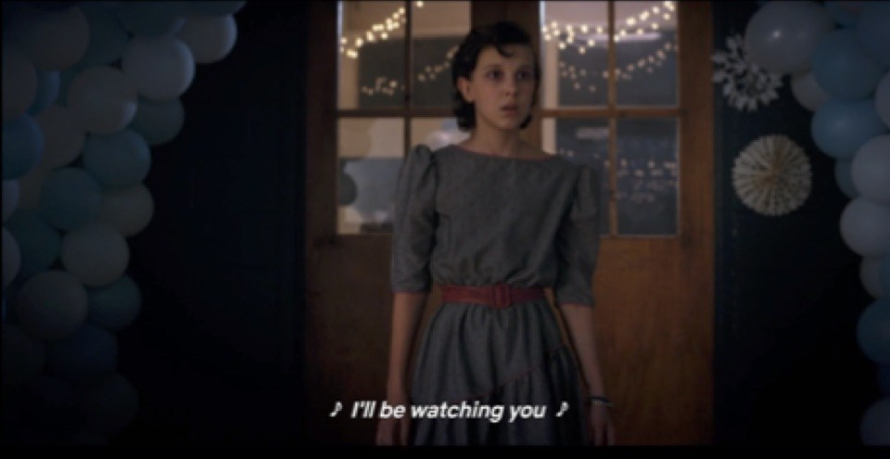Figure 5: Eleven’s Snow Ball makeover (2.09). Copyright: Netflix.
One last element of Eleven’s appearance in this final scene of Season Two, is the blue bracelet that she wears on her left wrist. The bracelet can be traced back visually in the series to Hopper’s dead daughter. Careful examination of the show then reveals that Hopper also wears the bracelet, through both seasons presumably in memory of his daughter. That he has (apparently) given it to Eleven as an accessory for the dance may be seen, as Reddit users observe, as a signal that “she’s now daddy’s girl” (Kurp). In this final scene, The Police’s “Every Breath You Take” plays, a wholly appropriate tune for the resolution of the season. The song, which promises that the male singer will “be watching you” reminds us that Eleven exists, in the series, “through and for the gaze of others” (Bourdieu 66). Whether her appearance is viewed and controlled by scientists, well-meaning policemen or a gang of teenagers, she is always on display, a doll in a case, her purpose to communicate the desires of the group. As Mike and Eleven dance to the song, so do most of the other cast members, in perfectly aligned heterosexual pairs, restoring the symbolic order and communicating a successful, heteronormative resolution to the storyline.
Both seasons of Stranger Things look for happy endings that resolve the discomfort created by Eleven’s irrational, abject power and strength. The first season has her giving her life for that of the boys, martyring herself in a Joan of Arc moment of supreme self-sacrifice. This is well within the traditional role of the second sex. And it is directly within Lacán’s (and Butler’s) Law of the Symbolic, whereby women are characterized in terms of connection, self-sacrifice and success in relationships (Elam). The second season ends with Eleven dressed appropriately and femininely and it also includes a kiss between her and Mike, reinforcing the acceptable performance of gender on her part. Each ending is a nod to the necessary elements of Butler’s “grid of cultural intelligibility” (208) and Di Mare’s “norms of etiquette and propriety.”
Eleven Cosplay: Rejection of Facile Resolutions
The creators of Stranger Things may put great effort into the resolution of discomfort and symbolic dissonance, but many fans of the show reject this effort. As I will demonstrate, for these fans, it is the discomfort of Eleven’s non-conformity and the dissonance displayed in her character that is so appealing. At the same time, as admirers of both Stranger Things and its young heroine, many fans find it not only acceptable but essential to create their own versions of Eleven, imposing their personal visions of her identity on the template of the character in much the same way as do those in the series. In this way, Eleven continues to be created and recreated through the gaze of others.
Fan participation in the creation of new forms of media has been well documented by fan studies scholars like Henry Jenkins. Cosplay, the practice of dressing up like a character from a media entertainment, is just one element of this participation, which Jenkins terms “participatory” or “convergence” culture (2). Jenkins uses these terms to describe the way that fans actively interact, work and play in their consumption and celebration of popular culture instead of remaining passive consumers of media. Twenty-first century fans feel empowered to take ownership of both individual characters and whole franchises in order to create new, fan-generated content, while corporate interests increasingly encourage these kinds of active participation with a “healthy respect for their value” (Jenkins 143). While Jenkins does not speak specifically of cosplay, his conclusions about the way that fans claim ownership by working with and changing characters from film, television, books and games is clearly relevant to the cosplay and cosplayers, as part of what Jenkins terms “trans-media storytelling” (8).
In July of 2017, I attended RTX, the Rooster Teeth Expo, a convention in Austin, Texas. RTX yearly draws 30,000 or more people for each of its four days, all of whom end up standing in line to register. These lines, at times, may be several hours long. In my research, I have often found these lines to be perfect places to find cosplayers willing to talk to me about their cosplays, their choices and their thoughts on characters and character portrayals.^{[2]} In Austin, I met Sarah,^{[3]}who was cosplaying Eleven. She wore a version of the pink dress featuring a similar white Peter-pan collar and the blue windbreaker from Season One. Sarah’s head was shorn and she had a small trail of fake blood coming from one nostril. In short, she had chosen the “Weirdo Barbie” version of Eleven to portray.
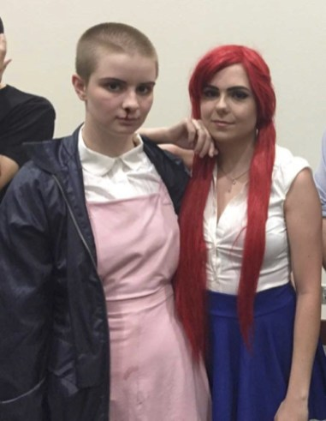Figure 6: Sarah as Eleven with Zoe as Erza Scarlett. Copyright: the Author.
When I asked Sarah why she had chosen Eleven, she told me that she “identified with” the character immediately when she first saw the program (Sarah). Sarah detailed how she appreciated Eleven’s struggle to overcome obstacles and a troubled past and admired her as a “badass independent female.” Sarah was also clear that one of the things she admired most about Eleven was that the character “is all business with no romantic entanglements” (Sarah).
In most ways, this interpretation fits with the visual version of Eleven that she had chosen to cosplay, performing the point at which Eleven sheds her wig and uses her powers to fight. It seems revealing, however, that instead of choosing the more liminal and outsider version of Eleven in Season One, (in the hospital gown), Sarah chose the more protected, more covered version of the character. This fits with her description of Eleven as “strong,” and interestingly, also with her view of Eleven as “someone who accepts her fate” (Sarah). This last observation strikes me as a perceptive interpretation of how Eleven’s character may know that the Barbie costume that the boys have made her is not appropriate, as comical as the similar outfit in which E.T. was clothed. The boys in Season One seek to make Eleven “pretty” so that she can conform to cultural norms of beauty and femininity and not draw attention to them all. Viewers are left to draw their own conclusions about how much Eleven embraces that effort herself. Eleven, in Sarah’s view, chooses to reject that effort and embrace her dangerous, abject irrationality as her “fate.” This interpretation understands Eleven as inherently and fundamentally abject and irrational, a powerful “other” alienated from social norms of gender and appearance.
In addition, however, this interpretation is interesting because Sarah is choosing to ignore other evidence about Eleven from the show. In the episode where this version of Eleven appears, she uses her power, but then timidly asks Mike if she is “still pretty” (1.02). For many, this would confirm her awareness of the importance of her appearance to the group and particularly, to Mike. Eleven’s interest in Mike is the other part of the character which Sarah is choosing to disregard; what could be described as Eleven’s concern about fitting in and her romantic (or at least friendly) emotional interest in Mike. Sarah, however, did not read the character in this way, and in fact expressed dismay at the scene in the finale (1.08) where Mike kisses Eleven. Sarah’s assertion to me that Eleven “has no time for the men” is supported by her belief that the Duffer brothers “made” Eleven accept that kiss (Sarah). In this way, Sarah is defending the character created by those very men from their own choices about her. Sarah wants to see Eleven as strong, independent and not interested in boys, and so she applies that vision of the character onto both her interpretation of the character and her own performance of Eleven as well. This interaction with Eleven by a fan and cosplayer is the type of activity Jenkins defends as the “public right of cultural participation,” whereby they take ownership and assume the authority to make choices, or explore “alternative points of view” within the universe of a media entertainment (190).
To offer another example, in early 2018, I spoke with Raleigh, a young trans man who was attending Visioncon, a convention in Branson, Missouri. Similar to RTX, many of the thousands of fans in attendance were dressed in cosplay. Though Raleigh was, at the time of our conversation, cosplaying Lup, a female character from The Adventure Zone, he expressed intense devotion to the character of Eleven and his cosplay of “them” (Raleigh). Raleigh was insistent on using the gender-neutral pronoun for Eleven (they/them) as his interpretation and understanding of the character was as gender fluid and ambiguous. My conversation with Raleigh took place well after the release of the second season, which features Eleven’s jealousy about Mike in regards another female character as a significant part of the story. That jealousy, combined with her dress at the end of the second season and her happy and clearly consensual kiss with Mike, suggest both a heterosexual and female-identified position that allows her to be “resolved” in the Duffers’ grid of cultural intelligibility.
Raleigh, however, felt perfectly free to reject this interpretation and this (in his view) imposition of gendered identity and sexual preference on Eleven. He expressed disappointment at the kiss at the end of the second season and insisted on continuing to embrace a more androgynous and less defined version of Eleven. Raleigh explained that like Sarah, he cosplays the most ambiguous version of Eleven’s look, with the shaved head, bloody nose and ragged pink dress. He shared that what “I like is the ambiguity. I think a lot of people like that” (Raleigh). Raleigh, like Sarah before him, is engaging in participatory culture and appropriating a character who is ripe for interpretation, because of the “ambiguity” of her position. As Jenkins suggests, fans, in believing that “heroes belong to everyone” often use participatory culture to “draw out aspects of the emotional lives of characters or otherwise get in their heads” (Jenkins 160-161).
Raleigh may very well be right about Eleven’s popularity being seated in her (or their) ambiguity. In the years since the premiere of the first episode, I have seen many Eleven cosplayers. However, I have never seen or met an Eleven cosplayer who did not wear the iconic dirty pink dress with a bloody nose. A Google image search for “Eleven cosplay” will reveal hundreds of cosplayers the majority of whom wear that ambiguous costume of pink dress with bloody nose, with or without the wig. Given the amount of effort that the program puts into resolving the discomfort of “Weirdo Barbie,” it is striking how many fans prefer precisely that liminal image, as it allows them the freedom to see what they want to see in the character, and impose their vision of her/them on the template of her/their appearance.
Conclusions: Discomfort and Normalization
Throughout this paper I have asserted that there is a Eleven’s appearance is manipulated to conform or not to gendered norms. Her irrational abjection is emphasized at times to show power. But there is also an element of paper doll in her characterization. And, as it happens, one can indeed buy paper doll sets of Eleven on Etsy or print a ready-made one from YahooTV (Woo). The article that accompanies the paper doll includes printable notes saying that “You can dress up the paper doll as the frightened Eleven from Dr. Brenner’s experiments. Or dress her up as Elle, Mike’s odd new friend in Nancy’s outgrown dress. Or mix and match the different looks!” (Woo). This emphasizes the way that Eleven’s appearance links to her characterization, and additionally how fans should feel free to appropriate these different looks, mixing and matching them to suit themselves.
The character of Eleven in Stranger Things offers us the opportunity to reflect on how women’s bodies are used as blank slates upon which society’s, or individuals’ values are displayed. When we meet Eleven, she is nearly naked, shorn even of hair. This presentation gives us all- both the characters in the show and the viewers at home, an opportunity to appropriate her appearance as a way of communicating what we want or hope the reality of her interior life to be. (The fact that she speaks so little only adds to our perception of her as a nearly inanimate doll to be manipulated.) The way that the characters in the show then impose their own visions of her identity on her through a series of makeovers, mirrors fans’ assertion of their right to participate in the collective identity building of Eleven “on their own terms, when and where they wish” (Jenkins 175).
In Stranger Things the Duffer Brothers have created an example of a young woman who, in the words of Bourdieu, exists “first through and for the gaze of others” as a “body-for-others,” on which society can display their cultural values (66). Eleven, as imagined in the show bible, is an alien, asexual and ambiguous (Duffer n.d.). This positioning of her in the program leaves her open to the series of makeovers that characters within the program and viewers outside the program feel free to perform on her body. The discomfort that viewers originally feel upon seeing the vulnerable body of Eleven (1.01), offers the opportunity to resolve (or not resolve) that discomfort through the imposition of different styles, fashions and interpretations of Eleven’s identity. As such, Eleven’s “weirdo” appearance invites a kind of participatory effort of identity building in both gender and style. We, as viewers, are ultimately left with little information as to Eleven’s own feelings and preferences, a fact which only makes her more compelling as it allows everyone to believe that their vision for her is the one that truly represents her interior life. In the end, Eleven remains a mysterious, silent doll whose otherness can be manipulated to fit a vision of conformity or rebellion.
Works Cited
AwasthiBhuvanesh. “From Attire to Assault: Clothing, Objectification, and Dehumanization–A Possible Prelude to Sexual Violence?”Frontiers in Psychologyvol. 8,2017, p. 338.https://www.ncbi.nlm.nih.gov/pmc/articles/PMC5344900/. Accessed 25 October 2018.
Ayman, U and AK Kaya. “Consumption of Branded Fashion Apparel: Gender Differences in Behavior. Social Behavior & Personality: an international journal, vol. 42, 2014, pp. 1-8.
Barnes, Ruth and Joanne B. Eicher Eds. Dress and Gender: Making and Meaning. Bloomsbury, 1993.
Barrig, Manuela. El mundo al revés: Imágenes de la mujer indígena. FLASCO, 2001.
Bourdieu, Pierre. Masculine Domination. Stanford University Press, 2001.
Butler, Judith. Gender Trouble. 1990. Routledge, 2007.
Carruthers, Elsa M. “Revisiting the Monstrous Feminine and Monster Parents in Stranger Things. ”Uncovering Stranger Things: Essays on Eighties Nostalgia, Cynicism and Innocence in the Series, edited byKevin J. Wetmore Jr., McFarland, 2018,pp. 128-134.
Di Mare, Fabiola. “El rol de la mujer en la prensa venezolana del siglo XIX.” Diario de los Andes, 21 April 2013. P. 22. Translation courtesy of the author.
Duffer, Matt and Duffer, Ross, Montauk Pitch Book, (n.d.), http://www.zen134237.zen.co.uk/Stranger_Things/Stranger_Things_-_Bible.pdf
Elam, Amanda Brickman. Gender and Entrepreneurship. Elgar, 2014.
Fishman, Elana. “How Eleven’s ‘Bitchin’ Stranger Things 2 Makeover Came Together.” Racked. 31 October, 2017. https://www.racked.com/2017/10/31/16571754/stranger-things-2-costumes
Fortenberry, J. Dennis. “Puberty and Adolescent Sexuality.” Hormones and Behavior, vol 64, no. 2, pp. 280–287.
Heath, Jennifer. 2008. The Veil: Women Writers on its History, Lore and Politics. University of California Press, 2008.
Jenkins, Henry. Convergence Culture: Where Old and New Media Collide. New York University Press, 2006.
Kaufler, Melissa. “Women as Stranger Things: Frankenstinian Exploitation and Weaponization
Of Female Bodies.” Uncovering Stranger Things: Essays on Eighties Nostalgia,Cynicism and Innocence in the Series, edited by Kevin J. Wetmore Jr., McFarland, 2018, pp. 84-92.
Kristeva, Julia. Powers of Horror: An Essay on Abjection. Columbia University Press, 1982.
Kurp, Josh. “This Tiny (And Heartbreaking) Stranger Things 2 Detail Connects Hopper and Eleven.” Uproxx, 11 November 2017. https://uproxx.com/hitfix/stranger-things-bracelet-eleven-hopper/.
Lunceford, Brett. “Clothes Make the Person? Performing Gender Through Fashion.” Communication Teacher vol. 24, no. 2, 2010, pp. 63–68.
Luther Hillman, Betty. Dressing for the Culture Wars. University of Nebraska Press, 2015.
Menta, Anna. “Stranger Things 2’s Fans at War Over Episode 7, ‘The Lost Sister.” 2 November 2017.https://www.newsweek.com/stranger-things-fans-episode-7-700289.Accessed 30 October 2018.
Merriam-Webster. “Pretty.” https://www.merriam-webster.com/dictionary/pretty. Accessed 30 October, 2018.
Miyamoto, Ken. “How to Sell Your TV Series the Stranger Things Way.” Screencraft. 26 October 2017. https://screencraft.org/2017/10/26/how-to-sell-your-tv-series-the-stranger-things-way/.
Nichols, Elizabeth Gackstetter. “Decent Girls with Good Hair: Beauty, Morality and Race in Venezuela”Feminist Theory, vol. 14, no. 2, August 2013, pp. 171-186.
Nicholson, Rebecca and Frank Hulley-Jones. “The Duffer Brothers.” 14 October 2017 https://www.theguardian.com/tv-and-radio/ng-interactive/2017/oct/14/duffer-brothers-spielberg-80s-stranger-things. Accessed 25 October 2018.
Raleigh. Personal Interview. Branson, Missouri. 25 February 2018.
Roach, Emily E. “AIDS, Homophobia and the Monstrous Upside Down: The Queer Subtext of Stranger Things.” Uncovering Stranger Things: Essays on Eighties Nostalgia, Cynicism and Innocence in the Series, edited by Kevin J. Wetmore Jr. McFarland, 2018, pp. 135-155.
Sarah. Personal Interview. Austin, Texas. 7 July 2017.
Siebert, Valerie. “Stranger Things Creators Originally Wanted to Kill Eleven.” The Daily Mail. 6 November, 2017. http://www.dailymail.co.uk/femail/article-5055939/Stranger-Things-creators-originally-wanted-KILL-Eleven.html.
Sonofra, Tutmothis. “Girls With Short Hair are Damaged.” Return of Kings. January 7 2014 http://www.returnofkings.com/26763/girls-with-short-hair-are-damaged.
Stranger Things. Created by The Duffer Brothers. Netflix.2016-present.
Wigler, Josh. “Stranger Things Creators Break Down Season 2 Eleven’s Story.” The HollywoodReporter. October 31 2017. https://www.hollywoodreporter.com/live-feed/stranger-things-creators-break-down-season-2s-eleven-story-1053344.
Biographical Note:
Dr. Elizabeth Gackstetter Nichols is a Professor of Spanish and Latin American Cultural Studies at Drury University. Nichols specializes in the Popular Culture of the Americas, Women’s Studies and International Beauty Practices. Nichols is the author of four books: a cultural encyclopedia of popular culture in Latin America, an encyclopedia of world beauty practices and the recently published Beauty, Virtue, Power and Success in Venezuela: 1850-2015. Her most recent book chapters include “Virgin Venuses: Beauty and Purity for ‘Public’ Women in Venezuela” and “Ultra-Feminine Women of Power: Beauty and the State in Argentina” both in Women in Politics and Media: Perspectives from Nations in Transition. Currently, Nichols is researching cosplay, gender and identity in the United States and Latin America. Her article ““Youth Cosplay and Produsage: Creative Rejection of Social Norms” has recently been accepted for publication. She has written numerous articles on cosplay for web-based publications and blogs at www.cosplaymom.com

^{[1]}Emily Roach, in her article “AIDS, Homophobia and the Monstrous Upside Down” additionally suggests Eleven’s appearance as symbolically one of an AIDS patient, with the number “calling to mind the numbering of patients who were diagnosed with HIV in the early stages…” In either event, the image is one of damage, sickness and abuse. Indeed, I find that critics’ and scholars’ ability to see diverse iterations of different (but similar) symbolic representations of incompleteness in Eleven to be further evidence of her position as a paper doll onto which we are all invited to apply new interpretations.
^{[2]}Following the permissions that I have received from the Institutional Review Board of my university, I approach cosplayers and ask for their permission to speak with them. If they agree, I provide both verbal and written explanation of my purpose and their rights in regards the information they gather. I additionally give participants my contact information for follow up discussions and so they may contact me to withdraw consent or request to see the transcription of our interviews. For these interviews, I use a set of basic questions on cosplay that have been approved by the IRB and then often use follow up questions to learn more.
^{[3]}In interviews, I always give cosplayers the opportunity to tell me how they would like to be identified in my writing. Many cosplayers use “stage” or performance names, which may or may not conform to their biological gender. Therefore, I always ask their preferred pronoun as well.
Refractory: A Journal of Entertainment Media
Published by Screen and Cinema Studies, Department of Media and Communication, Swinburne University of Technology
ISSN: 1447-4905

